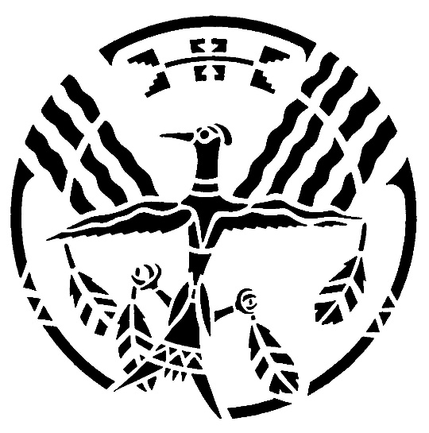
VIRTUAL VISION QUEST
led by Wanda Patterson, Chair
American Indians Committee
Fielding Lewis NSDAR
May, 2025
_________________________________________
Cochise and the Apache make peace
I have always loved the 1950 movie BROKEN ARROW, starring Jimmy Stewart, Jeff Chandler, and Debra Paget; however, I did not know until recently that the story was based on actual events concerning the Apache Chief Cochise and the Indian wars in Arizona in the late 1800’s. In the movie Stewart plays the part of Tom Jeffords, a Civil War scout for the Union Army, who traveled west to look for gold in Arizona at the end of the war. Amazingly he became acquainted with Cochise. Their friendship was remarkable because the fearsome Apache chief and his warriors were at war with white settlers and the U.S. Army. When the U.S. government attempted to negotiate peace with Cochise and his people, government representatives were unable to make contact with Cochise until Jeffords made the introduction. The movie script injects a fictitious love story between Jeffords and a beautiful young Apache girl to spice up the tale, but most of the rest of the movie is based on historical facts.
The Apache Stronghold in the 1860’s was the Dragoon Mountains in Arizona. (I’ve actually been there!) Cochise was determined to prevent whites from traveling through the area, and he and his warriors are said to have killed as many as four hundred settlers and soldiers. Apache warfare was successful because they used sudden ambushes when their foes were trapped in confined areas such as canyon walls and streams. The Apache lost few warriors because they were experts at choosing locations for attacks. They were able to disappear as if by magic when the battles ended. It is interesting to note that the Apache prayed several times daily to their one God, particularly praying for help when threatened.
Cochise was apparently a very handsome man. According to a source who had actually seen the chief, “He was as fine a looking Indian as one ever saw. He was about six feet tall and as straight as an arrow, built from the ground up, as perfect as any man could be.” No photo exists of Cochise, but he was said to look very much like his youngest son Naiche, pictured below with his wife.
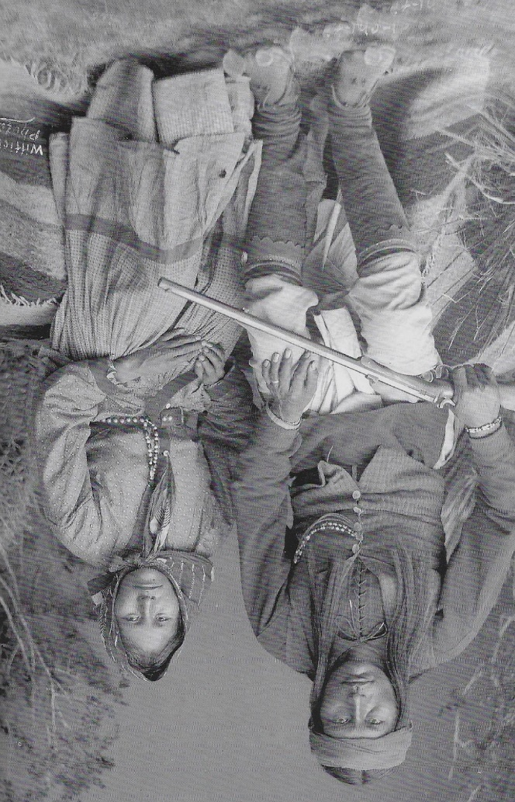
Cochise was chief of the Chiricahua, the largest of several bands of Apache. (Other primary Apache bands included the Mescalero, the Jicarilla, and the Lupan.) The Chiricahua had primarily been at war with Mexicans for many years. As early as 1835 the Mexican government paid bounties for the scalps of Apache warriors, their women and children. Apache attempts at peace with the Mexicans were repeatedly rebuffed, so their enmity continued for many years. Cochise’s father was killed by the Mexicans.
Apaches began their war against white Americans around 1860 when settlers, gold miners, and the U.S. Army began to invade Apache territory. The Indians were primarily fighting to halt the increasing intrusion of whites into their hunting grounds. As mentioned previously, Apache warriors were masters of the ambush, and for several years they ruled their area of Arizona. The Butterfield Overland Mail Company, for example, lost so many mail riders that they were entirely barred from delivering the mail. No white man dared venture into the Dragoon Mountains for fear of Cochise and his band.
After numerous failed attempts at negotiating a peace treaty with the Apache, President Ulysses S. Grant selected Major General Oliver Otis Howard to lead a delegation to Arizona to try again to make peace with the Indians. Howard’s orders were brief: use his own judgement for terms, but make peace with Cochise.
A graduate and later an instructor at West Point, General Howard had been promoted to colonel in the Union Army in the first Battle of Bull Run. By the time he led troops in the Battle of Seven Pines, he had become a general. He was wounded twice in the arm during that engagement, and his right arm was amputated. For his gallantry Howard was awarded the Congressional Medal of Honor. Despite having only one arm, he continued to distinguish himself at Antietam, Sharpsburg, and Cemetery Ridge. He concluded his service with Sherman at the Battle of Atlanta and the infamous March to the Sea.
Howard was known as “the Christian General” because he frequently based his military decisions on his religious beliefs, and he required his troops to attend Bible classes. After the war he was appointed to lead the Freedmen’s Bureau and helped establish Howard University to train Black lawyers, doctors, and teachers.
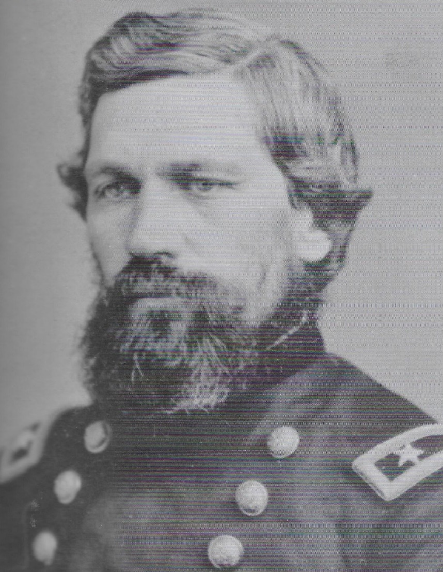
The Christian General
General Howard and his aide went to Fort Apache in 1872, hoping to make contact with Cochise, but had no success in contacting him for over three weeks. They traveled on to Fort Tularosa in New Mexico, having been told that they might find Cochise near there. Again having no success, they were told to look for a man named Jeffords who might lead them to the chief.
Thomas Jeffords was the only white man known to be able to ride into the Apache Stronghold and live to tell about it. Jeffords had met Cochise while prospecting in the Dragoon Mountains area when he was captured by some of Cochise’s men and was taken to the chief. Jeffords impressed the Apache with his bravery, and Cochise spared his life because he was one of the only white men the chief had encountered who had bothered to learn to speak Apache. The two men became friends, a great tribute to Jeffords because he could say that he had won the friendship of the awesome chief of the Apache.
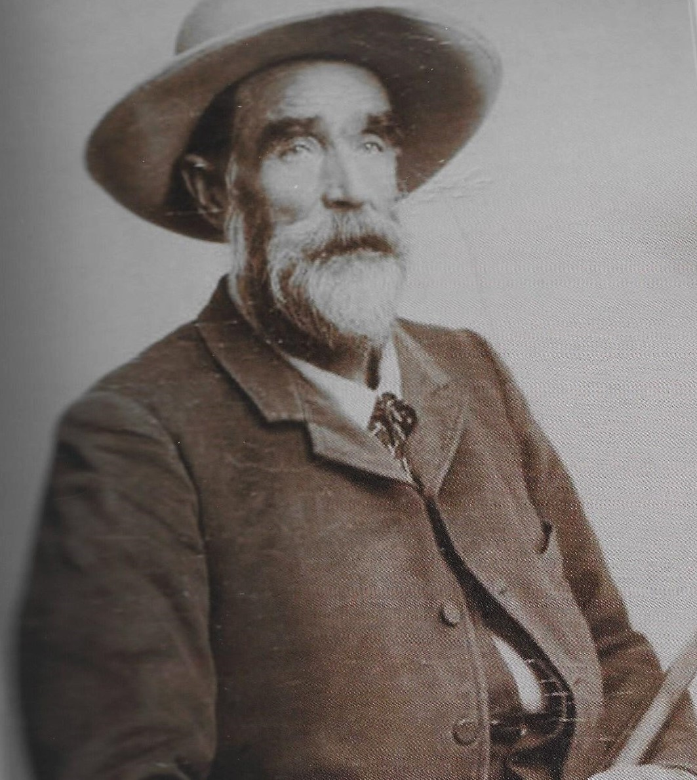
Tom Jeffords
General Howard met Tom Jeffords and introduced himself, saying, “I understand, Mr. Jeffords, that you know Cochise, and can find him. I have come here from Camp Apache to find you, and if possible, to get you to go to Cochise and induce him to come to me, for an interview.”
Jeffords replied, “General Howard, Cochise won’t come. The man that wants to talk to Cochise, must go where he is.”
When Howard asked Jeffords if he would take a message to Cochise, he answered, “No, General, but I will take you to Cochise.”
Jeffords, General Howard, Howard’s aide, and two Apache guides traveled by horseback for over two weeks to reach the Apache Stronghold. They met Cochise, talked peace, and Cochise gathered his sub-chiefs to describe Howard’s terms for a treaty. The sub-chiefs came great distances for the peace conference, which took place on some large boulders at a place known today as Council Rocks. General Howard sent orders to Fort Bowie that the Apache leaders were not to be attacked or taken prisoner as they came to the Stronghold. The group conferred for almost two weeks before a peace agreement was concluded. Most of the sub-chiefs accepted the terms of the treaty, but a few did not. The infamous Geronimo was one of those who refused and rode away to terrorize the area for a number of years before his final capture with only 34 men, women, and children remaining in his band.
Part of the peace treaty was the creation of the Chiricahua Reservation established by Cochise and General Howard at Apache Pass. Cochise promised to halt all attacks on American troops and to protect the roads leading in and around the pass. Thus, the Butterfield mail deliveries were safe once again. No part of the treaty was violated for the two years remaining in Cochise’s life. Tom Jeffords served as Indian Agent at the Reservation; and no whites, military or civilian, were allowed to enter the reservation without Jeffords’ permission. He remained a close friend of Cochise until the chief’s death in 1874. A portion of Jeffords’ office and living quarters are still visible on a hiking trail near Fort Bowie.
General Howard was severely criticized by the Army for establishing the reservation on Cochise’s terms without the supervision of the Army. However, Howard’s
agreement was far more successful than any of the other treaties drawn up and immediately broken by military representatives.
According to a Cochise biographer, “No other leader had succeeded in obtaining a reservation in his country, one which was run by the Indians in conjunction with their agent without military interference. Perhaps no other Apache chief exhibited more wisdom, courage, fighting ability, and control of his followers than had Cochise.”

